**002_AIP_AMDT**

**MODULES LIST**

**1. User Management Module**

* **Login and Authentication**: Separate login for external entities and internal users.
* **User Roles and Permissions**: Different roles like Originator, SCD Quality Check, Document Compiling Organization, and Server Team with specific permissions.
* **User Registration**: External entities can register and request access.

**2. Amendments Dashboard Module**

* **Dashboard View**: Displays the status of all previous amendments.
* **Search and Filter**: Allows users to search and filter amendments based on various criteria like date, status, originator, etc.

**3. Amendment Initiation Module**

* **Create Amendment Form**: Originators can create and submit new amendment forms.
* **Form Fields**: Relevant details such as amendment type, description, supporting documents, etc.
* **Pending Status**: Sets the status of the newly created form to pending.

**4. Quality Check Module (SCD Quality Check)**

* **Review and Approval**: Allows SCD Quality Check team to review the amendment forms.
* **Commenting System**: If comments are required, the form is sent back to the originator with comments.
* **Approval Workflow**: If approved, the form is forwarded to the Document Compiling Organization.

**5. Document Compiling Organization Module**

* **Compilation Process**: Handles the compilation of the AIP portal.
* **Clarification Requests**: If clarification or amendments are required, the form is sent back to the originator with comments.
* **Final Preparation**: Once updates are done, the AIM files are prepared.

**6. Progress Log and Status Tracking Module**

* **Status Updates**: Tracks the status of each amendment form throughout the workflow.
* **Progress Logs**: Logs all actions taken on the amendment forms for audit purposes.
* **Notifications**: Sends notifications to users about the status changes and required actions.

**7. Approval and Authorization Module**

* **Approval Hierarchy**: Manages the hierarchy and flow of approval from originator to final publication.
* **Authorization Checks**: Ensures only authorized personnel can approve the amendments at different stages.

**8. Verification and Quality Assurance Module**

* **Final Review**: SCD Quality Check performs the final review of the AIM files.
* **Verification Process**: Verifies that all amendments are correctly implemented.
* **Approval for Publication**: Once verified, the documents are approved for upload.

**9. Publication and Server Management Module**

* **Document Upload**: The server team uploads the approved amendments to the AIM application.
* **Version Control**: Manages different versions of the AIP documents.
* **Backup and Restore**: Ensures that backups are taken and can be restored if necessary.

**10. Messaging and Communication Module**

* **Internal Messaging**: Allows communication between different entities involved in the process.
* **Email Notifications**: Sends email notifications for important updates and actions required.

**11. Audit and Reporting Module**

* **Audit Logs**: Maintains detailed logs of all actions taken within the application.
* **Reporting Tools**: Provides reports on amendment statuses, approval times, and other key metrics.

**12. Security and Compliance Module**

* **Data Security**: Ensures that all data is securely stored and transmitted.
* **Compliance Checks**: Ensures the system complies with relevant regulations and standards.

**13. Help and Support Module**

* **User Manuals**: Provides documentation and manuals for users.
* **Support Tickets**: Allows users to raise support tickets for any issues or questions.

**REPORTS LIST**

**1. Amendment Status Report**

* **Pending Amendments**: List of all amendments currently pending approval.
* **Approved Amendments**: List of all amendments that have been approved.
* **Rejected Amendments**: List of all amendments that have been rejected, including reasons for rejection.

**2. Originator Activity Report**

* **Amendments Submitted**: Number and details of amendments submitted by each originator.
* **Response Time**: Average time taken by originators to respond to comments or requests for clarification.

**3. Quality Check Reports**

* **SCD Quality Check Activity**: Number of amendments reviewed, approved, or sent back for comments by the SCD Quality Check team.
* **Common Issues**: List of common issues or errors identified during the quality check process.

**4. Compilation and Preparation Report**

* **Compilation Status**: Status of amendments in the compilation process.
* **Preparation Time**: Average time taken to prepare the AIM files for publication.

**5. Publication and Upload Report**

* **Upload Status**: Status of amendments uploaded to the AIM application.
* **Version History**: History of document versions and amendments uploaded.

**6. User Activity Report**

* **Login Activity**: Logs of user login activity, including successful and failed login attempts.
* **User Actions**: Detailed log of actions performed by each user within the application.

**7. Turnaround Time Report**

* **Average Turnaround Time**: Average time taken for an amendment to go through the entire process from initiation to publication.
* **Stage-wise Turnaround Time**: Time taken at each stage of the process (e.g., quality check, compilation, etc.).

**8. Compliance Report**

* **Regulatory Compliance**: Reports on adherence to regulatory requirements and standards.
* **Audit Trail**: Detailed audit logs of all actions and changes made within the system.

**9. Communication and Notification Report**

* **Message Logs**: Log of internal messages exchanged between different entities.
* **Notification History**: History of email and system notifications sent to users.

**10. Support and Issue Report**

* **Support Tickets**: List and status of support tickets raised by users.
* **Issue Resolution Time**: Average time taken to resolve support tickets and issues.

**11. Custom Reports**

* **User-Defined Reports**: Customizable reports based on specific criteria or filters set by users.
* **Scheduled Reports**: Reports that can be scheduled to run automatically at specified intervals.

**PROCESS FLOW**

**1. User Login and Authentication**

1. External and internal users access the AIP AMDT Portal.
2. Users enter their credentials (username and password) to log in.
3. The system verifies the credentials and grants access based on user roles (Originator, SCD Quality Check, Document Compiling Organization, Server Team).

**2. Dashboard and Overview**

1. Upon successful login, users are directed to their respective dashboards.
2. The dashboard displays the status of all previous amendments and pending tasks.
3. Users can search and filter amendments based on various criteria.

**3. Amendment Initiation**

1. **Originator**:
   * Clicks on "Create New Amendment" in the dashboard.
   * Fills out the amendment form with relevant details such as amendment type, description, and uploads supporting documents.
   * Submits the form, setting its status to "Pending."

**4. Quality Check (SCD Quality Check)**

1. **SCD Quality Check Team**:
   * Receives a notification of the new pending amendment.
   * Reviews the amendment form and supporting documents.
   * If comments are required, the form is sent back to the originator with comments for necessary changes (status: "Requires Revision").
   * If approved, the form is forwarded to the Document Compiling Organization (status: "Approved by SCD").

**5. Compilation and Preparation (Document Compiling Organization)**

1. **Document Compiling Organization**:
   * Receives the approved amendment form.
   * Reviews the form and prepares the AIM files.
   * If clarification or further amendments are needed, the form is sent back to the originator with comments (status: "Requires Clarification").
   * Once all updates are done, the AIM files are prepared and forwarded to the SCD Quality Check for final review (status: "Prepared").

**6. Final Quality Check (SCD Quality Check)**

1. **SCD Quality Check Team**:
   * Performs a final review of the prepared AIM files.
   * Verifies that all amendments are correctly implemented.
   * If everything is in order, the documents are approved for publication (status: "Approved for Upload").

**7. Publication and Upload (Server Team)**

1. **Server Team**:
   * Receives the approved AIM files.
   * Uploads the new amendments to the AIM application.
   * Updates the version history and ensures that backups are taken (status: "Published").

**8. Status Tracking and Progress Log**

1. Throughout the process, the system updates the status of each amendment form.
2. All actions and changes are logged for audit purposes.
3. Users can track the progress of their amendments through the dashboard.

**9. Notifications and Messaging**

1. The system sends notifications to users at each critical stage of the process:
   * Submission confirmation to originator.
   * Approval or comments from SCD Quality Check.
   * Requests for clarification or additional information.
   * Final approval and publication.
2. Internal messaging allows communication between different entities involved in the process.

**10. Reporting and Audit**

1. The system generates various reports such as Amendment Status Report, Originator Activity Report, Quality Check Reports, and more.
2. Detailed audit logs are maintained for compliance and review.

**11. Support and Issue Resolution**

1. Users can raise support tickets for any issues or questions.
2. The support team addresses these tickets and ensures timely resolution.

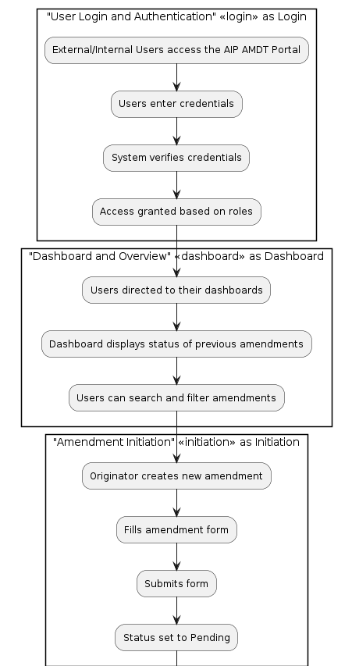

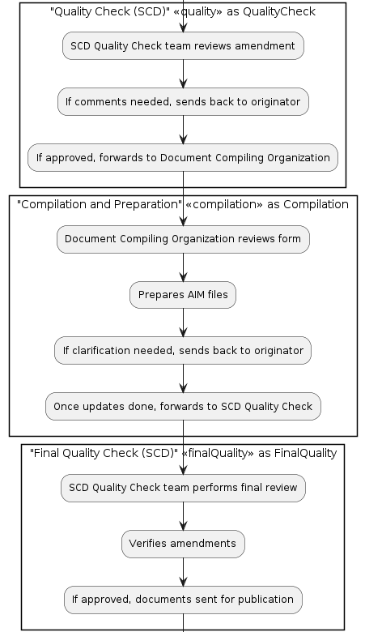

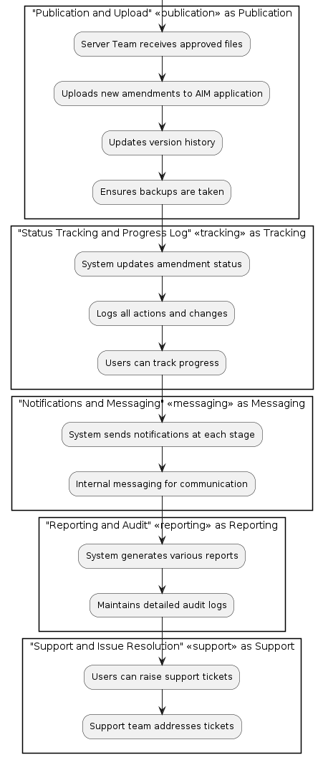

**Total Hours**

* **Total Hours for Front End Development**: 110 hours
* **Total Hours for Back End Development**: 130 hours
* **Total Hours for Database Development**: 45 hours
* **Total Hours for UX UI Development:** 20 Hrs